LINK AL PROYECTO: <https://www.tinkercad.com/things/hIKMsnFivju-funky-rottis/editel?sharecode=ngaatjvU5wpluN2ESkZqH-BF3LeY6yy4jOgMIHbo26g>

NELSON ORTEGA

CIRCUITO

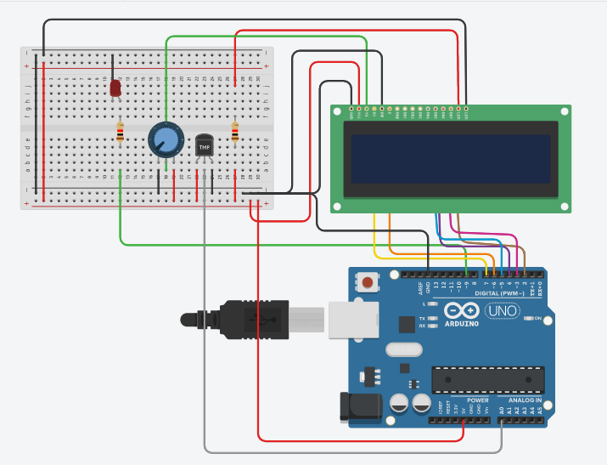

CODIGO

#include <LiquidCrystal.h>

LiquidCrystal lcd(7, 6, 5, 4, 3, 2);

int led = 0;

int sensorPin = 0;

void setup()

{

lcd.begin(16,2);

pinMode(9, OUTPUT);

}

void loop()

{

int reading = analogRead(sensorPin);

float voltage = reading \* 5.0;

voltage /= 1024.0;

float temperatureC = (voltage - 0.5) \* 100 ;

lcd.setCursor(0,0);

lcd.print(" UNICORDOBA ");

lcd.setCursor(0,1);

lcd.print("T= ");

lcd.print(temperatureC);

lcd.print(" Celsius");

if( temperatureC > 30.0){

digitalWrite(9, HIGH);

}

else if( temperatureC < 30.00){

digitalWrite(9, LOW);

}